- (4-1ex4) Solve 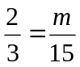
- (4-1ex6) Solve 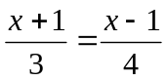
- (4-1ex6) Solve 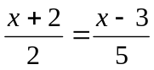
- (4-1ex2) A house casts a 50-ft shadow. A girl standing nearby casts a 10-ft shadow. Her height is 5 ft. What is the height of the house?

